# **Creation of Database**

#Author: Anikit Shahi

#Date: 11/09/2021

The first step is to establish a database, which is called School.

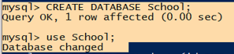

Figure : Creation of database

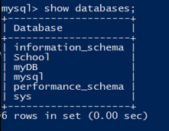

Figure : Checking Databases

After that, three tables are produced. They're as follows:

* Student
* Course
* Teacher

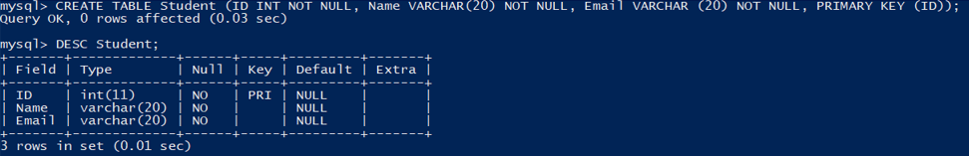

Figure : Creating Table Student

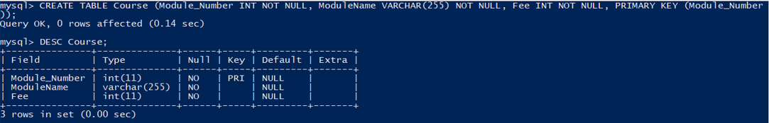

Figure : Creating Table Course

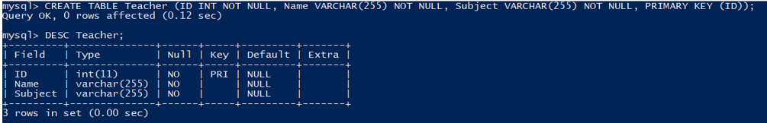

Figure : Creating Table Teacher

Values are now put in the tables above:

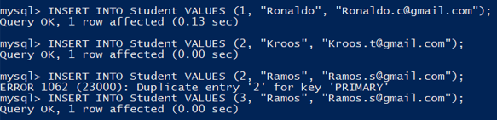

Figure : Inserting values into Student

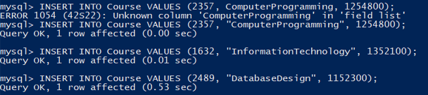

Figure : Inserting values into Course

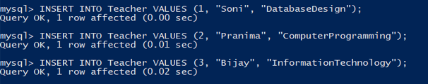

Figure :Inserting values into Teacher

Examining the tables and the data that has been entered into them.

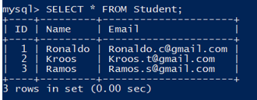

Figure : Student Table

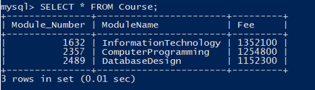

Figure : Course Table

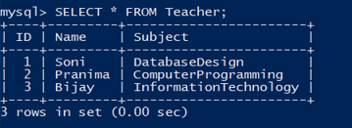

Figure : Teacher Table

With certain modifications in each table, it is updated.

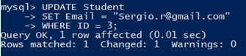

Figure : Updating Student

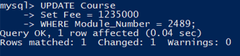

Figure : Updating Course

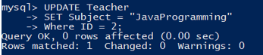

Figure : Updating Teacher

Examining the changes made to the tables.

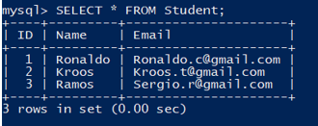

Figure : Result after updating Student

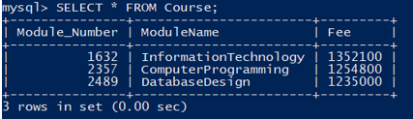

Figure : Result after updating Course

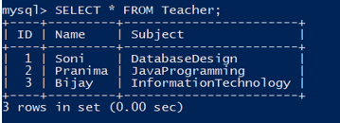

Figure : Result after updating Teacher

A entry from the student table has been removed from the database.



Figure : Removed a data from Student

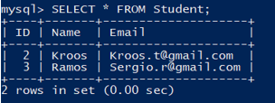

Figure : Result after removing a data in Student